KANSAS STATE GRANGE
QUILTS OF VALOR (QOV)

We are excited to invite quilters (and all who would like to learn)
to participate in this program of the KS State Grange.

Mission:
The mission of the National QOV Foundation is to “cover service members and veterans touched by war with comforting and healing Quilts of Valor.” The National Grange is a recognized partner of the Quilts of Valor Foundation Under Our Wings Program.

Guidelines:
The QOV Foundation has set up guidelines to comply as a QOV quilt, including overall finished quilt size.
A cloth QOV label will be attached to each completed quilt. A short bio of each recipient and photo of the presentation will be provided to the National QOV Foundation for their information and records.

How you can help:
Piece together one block or more! Work on your own or with others. Fabrics are your choices unless designated on patterns. Perhaps you don’t wish to quilt but would like to donate toward QOV supplies; i.e., batting and backing fabric. Please send / deliver donation to Randee Farmer or Lois Barber (see below).
Flint Hills Pomona Grange is hosting a Quilt Day on March 4, 2023, 9:00 am-4:00 pm
at the Burlington Library. Bring your sewing machine (if able), fabric and sewing tools
and ENJOY THE DAY. DON’T KNOW HOW?
COME LEARN WITH MANY OF US!
BRING A FRIEND!
We plan to work on both the National Quilt Block Contest (TBD) and QOV quilt blocks (attached).
2023 QOV QUILT INFORMATION

Presentation of Quilt(s):
Plan is to present at least two quilts during the State Grange Convention Annual Banquet in October 2023.

Patterns:
We have chosen 4 quilt block patterns to use for QOV 2023 quilts. Patterns are attached. Fabrics are your choice unless designated on patterns. Please use red, white and blue (both solid and pattern) as much as possible to keep with patriotic theme.

Send quilt blocks to:
Please complete your block(s) and send /deliver to Lois Barber or Randee Farmer by June 1 to allow time to sew quilt tops together and get quilted. (Mailing addresses below.)

Nomination submittal instructions:
Please submit nomination form (attached) of Veterans to receive QOV quilts by August 15 to Randee Farmer or Lois Barber. Confirmation of presentation will be communicated to submitting party by August 31 and more information will be requested at that time on the Veteran for introduction purposes. Veteran must attend the ceremony.
Looking forward:
The number of quilt blocks completed will determine how many quilts we are able to present to Veterans. Use this project as a membership tool. Get your Grangers and friends excited to participate.
Randee Farmer, 1210 State Street, Augusta, KS 67010 (316-644-1871)
Lois Barber, 31807 W 168th Ct, Gardner KS, 66030 (913-522-7452)

KANSAS STATE GRANGE
2023 Nomination Form
QUILTS OF VALOR

NAME OF VETERAN: __________________________________

SERVICE: ___________________________________________

GRANGE MEMBER ? _________________________________
(info only – not required to be awarded a quilt)

***********
SUBMITTED BY: (name)_________________________________
(Grange)________________________________

(phone number) __________________________

(email address) __________________________

(mailing address) _________________________
_______________________________________

Nomination submittal instructions:
Please submit nomination form by August 15 to Randee Farmer or Lois Barber. Confirmation of presentation for those nominated will be communicated to submitting party by August 31 and more information will be requested at that time on the Veteran for introduction purposes. Veteran must attend the ceremony.

Randee Farmer, 1210 State Street, Augusta, KS 67010 farmermd13@cox.net (316-644-1871)
Lois Barber, 31807 W 168th Ct, Gardner KS 66030 lois.barber@yahoo.com (913-522-7452)

2023 – Block #1

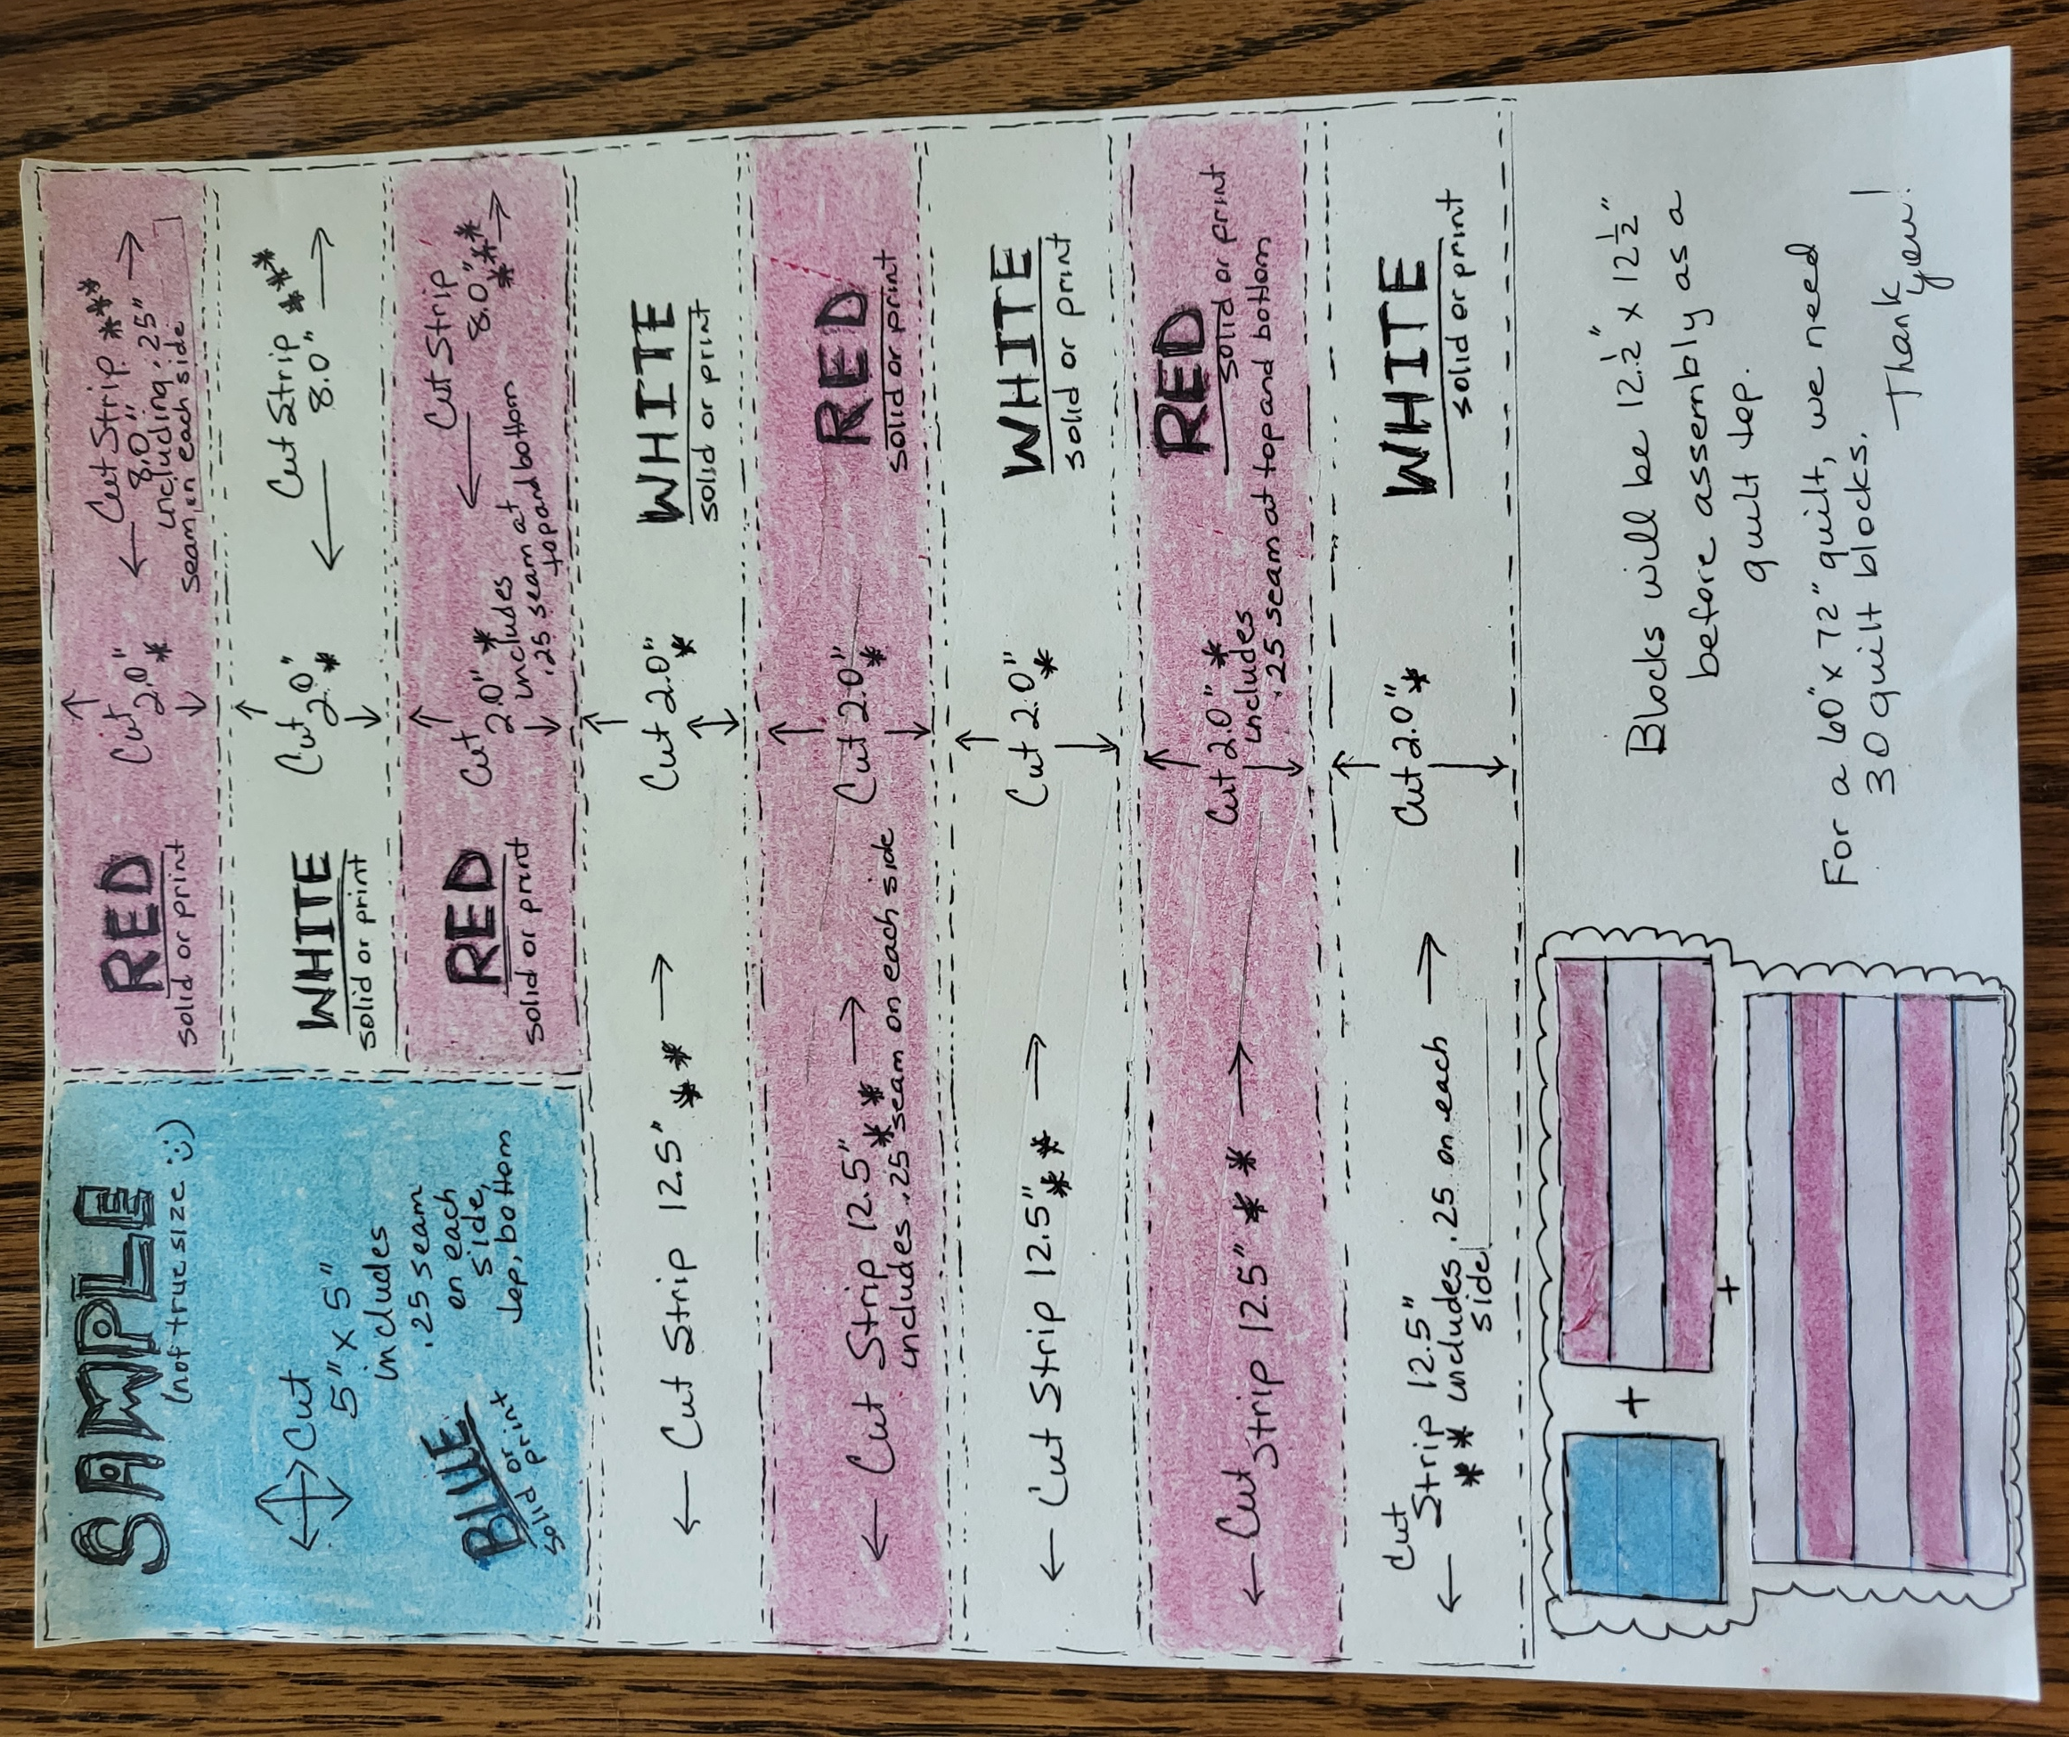

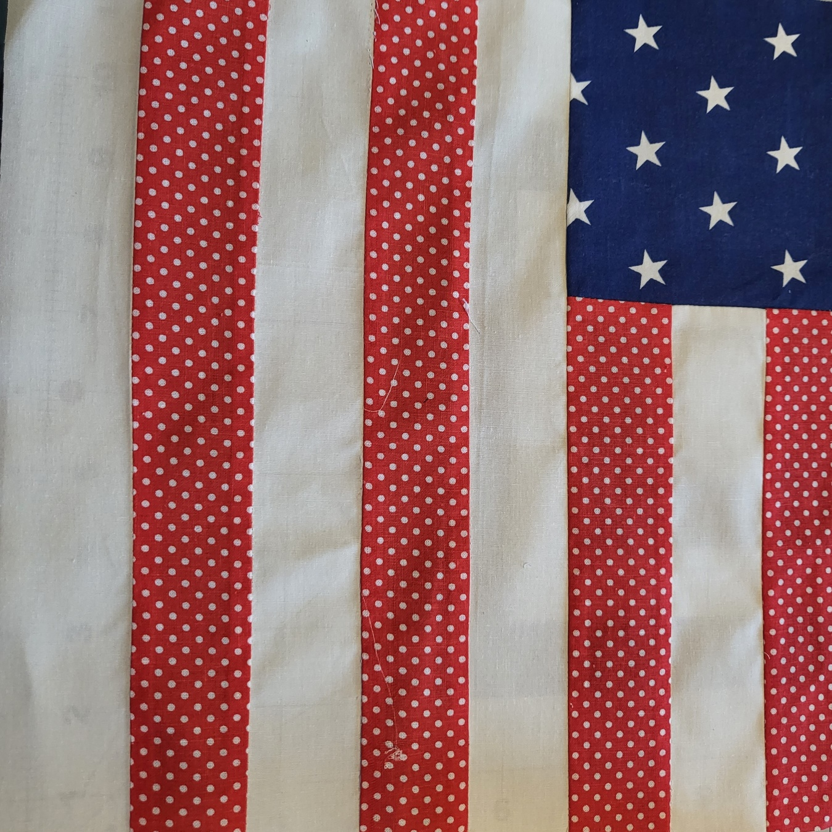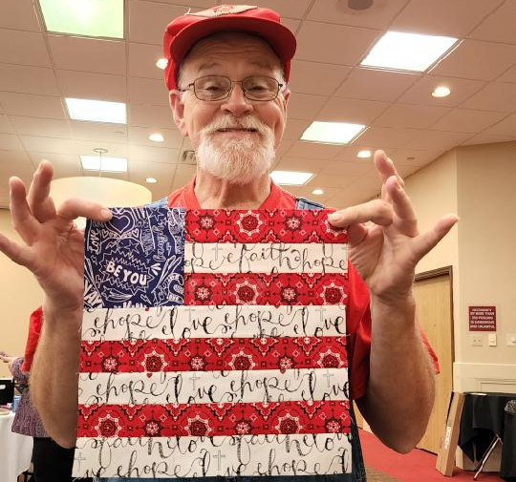
PLEASE NOTE:
RED STRIPES: use solid or red print fabric
WHITE STRIPES: use solid or white print fabric
BLUE BLOCK: use solid or blue print fabric

2023 – Block #2

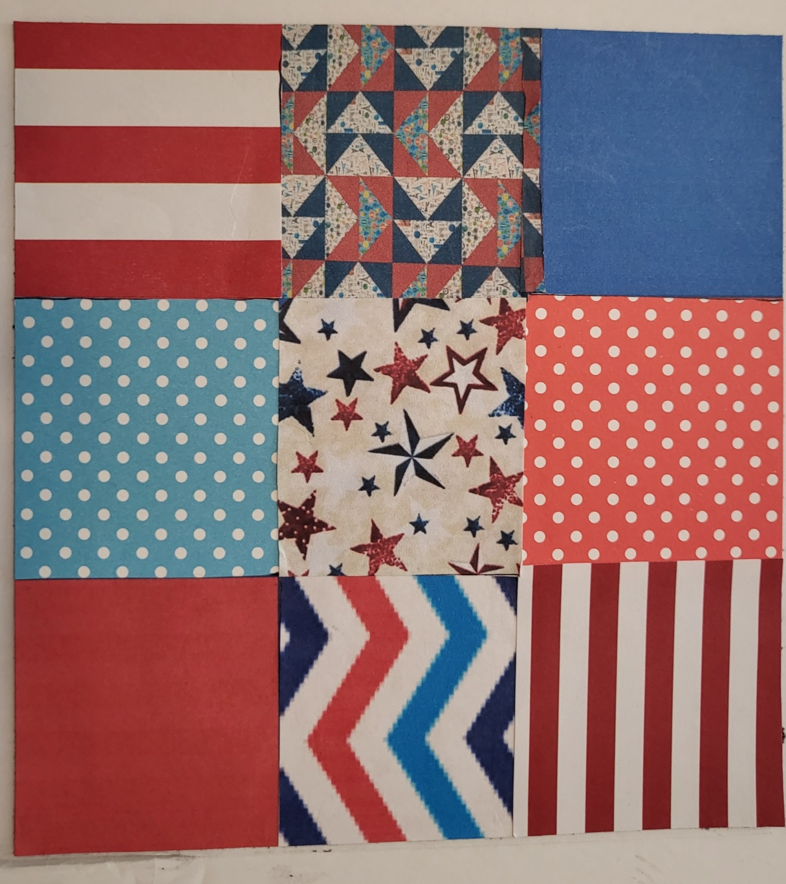

Each square is 4 ½“ square.
PLEASE NOTE:
PLEASE USE RED, WHITE, BLUE FABRIC – INCLUDE SOLID AND PRINTS

Assemble three squares (outer measurement will be 4 ½” x 12 ½”).
Assemble the three squares to another row of three
squares, then to another row of three squares.
Nine Patch Block should measure 12 ½” x 12 ½”.

PLEASE NOTE:
Make individual squares from red, white and blue fabric squares, solid or print. Each Nine Patch Block can be different.

2023 – Block #3

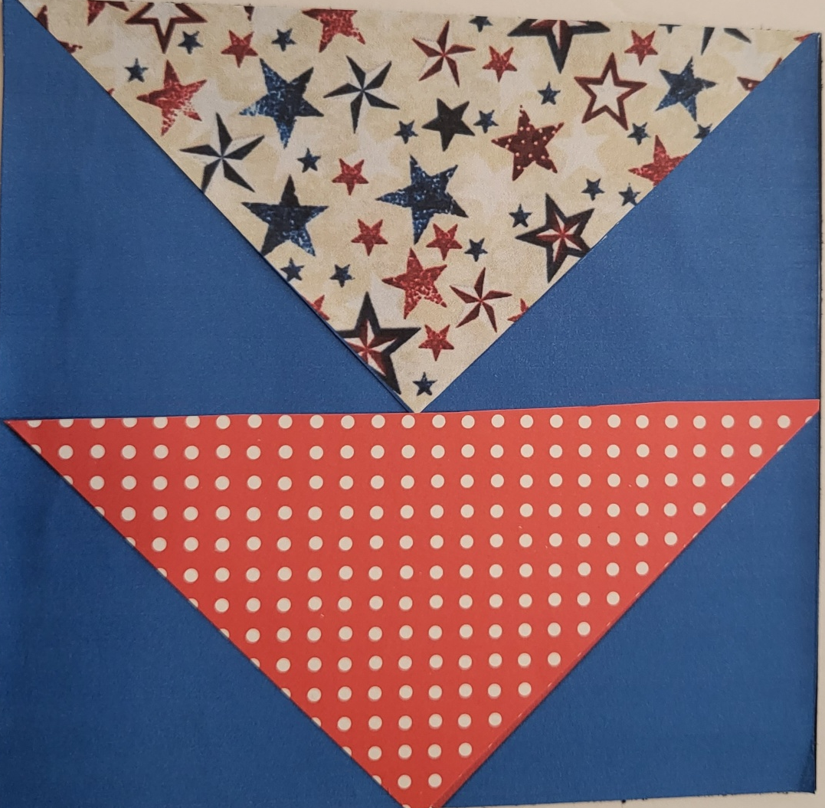
1 square
1 square
1 square
1 square

Cut one 9” solid color (red or blue) and
one 9” pattern fabric (pattern is not to have an up or down or stripes).
This will make 2 squares for this block.

Mark a diagonal line on the wrong side of each fabric.

Pair the two fabrics together and sew ¼” away from the diagonal line on each side of the line. Cut on the diagonal line. Press seams open.
You will have 2 completed squares
at this point. Trim each square to
8 ½”, if necessary.
Copy same procedure to complete
4 squares total. Sew 4 squares together.
(reference picture above)
PLEASE NOTE:
Please use solid blue as shown above (or red) in four of the triangles in the quilt block. Pattern pieces are to be red, white, blue print (pattern is not to have an up or down or stripes).

2023 – Block #4

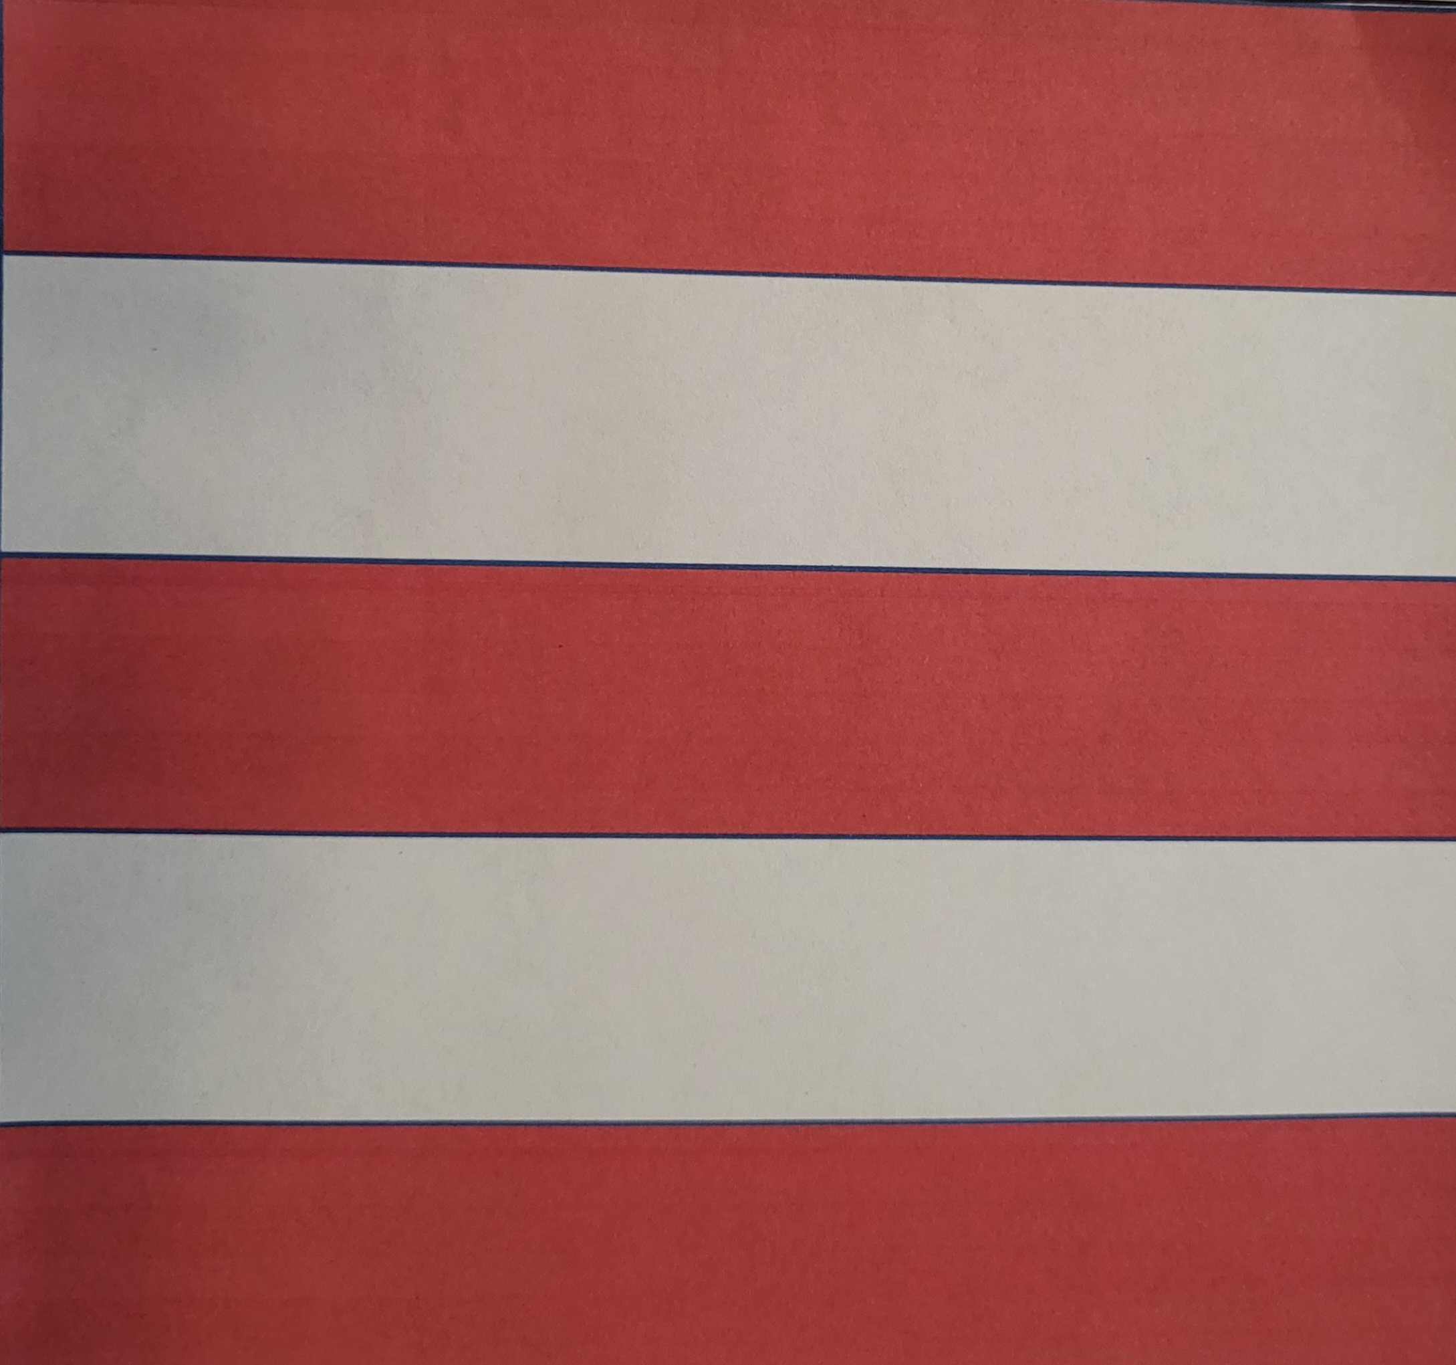

Each strip = 10 ½” x 2 ½”. Sew together with ¼” seams.
PLEASE NOTE:
RED STRIPES: Use red solid or red print
WHITE STRIPES: Use white solid or white print

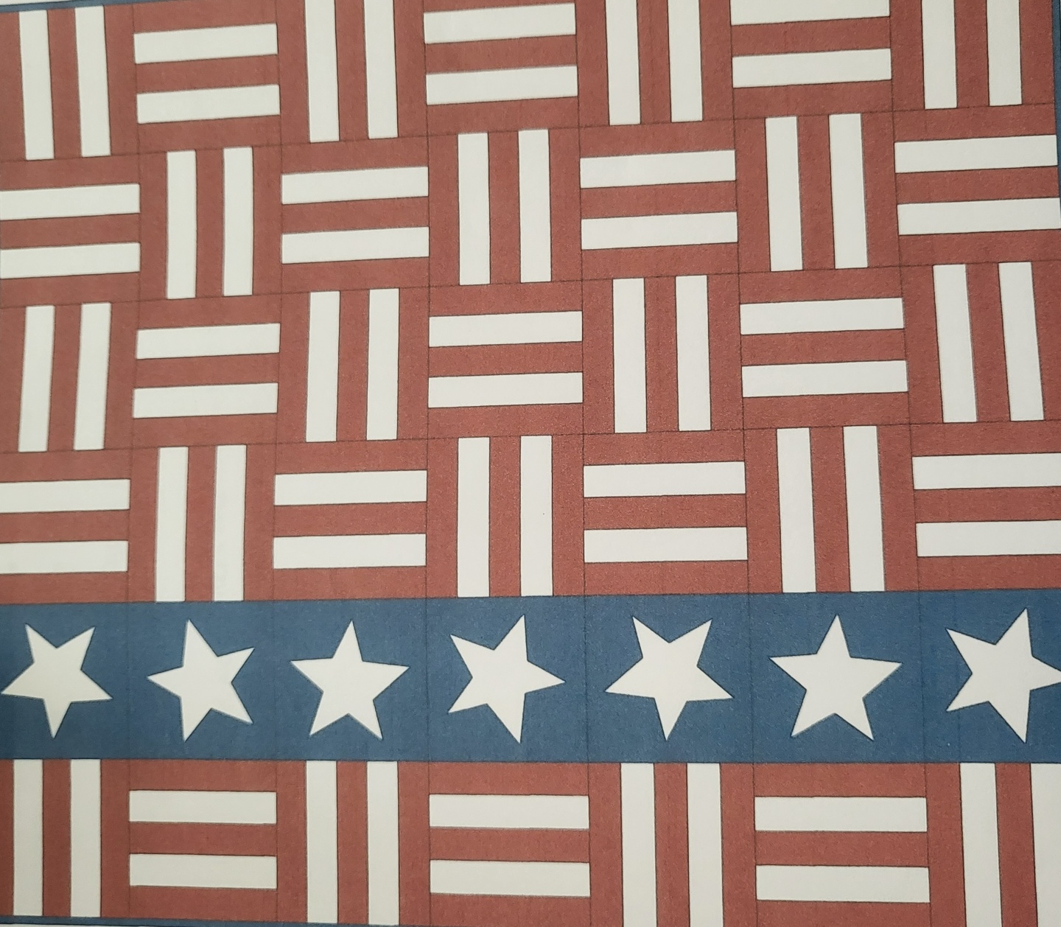
Completed
quilt

